Anna Sokolova (6482147)
About the data
A laboratory experiment was conducted to collect the data for the thesis. In this document I briefly describe the experimental design and procedure.
Experimental design
In the experiment, we employ the three games Г^{dyad/no}, Г^{con/no}, and Г^{con/dyad} with subgames Г^{no} (the one-shot Prisoner’s Dilemma), Г^{dyad} (the indefinitely repeated PD), and Г^{con} (PD with fine and compensation).
The experiment comprises five parts. Part 1: participants play exogenous Г^{no}, Г^{dyad}, and Г^{con}; Part 2: participants play either Г^{dyad/no} or Г^{con/no}; Part 3: participants play either Г^{con/no} or Г^{dyad/no}; Part 4: participants play Г^{con/dyad}; Part 5: SVO slider measure and a post-experimental questionnaire.
In parts 2 and 3 participants first choose whether to invest in embeddedness or not. Then, they are matched with a player who has made the same choice and then decide whether to cooperate or to defect in a subgame of their choice. In Part 4 participants choose whether to invest in dyadic or contractual embeddedness and then decide whether to cooperate or not. In each part the choices whether to invest and then whether to cooperate are made twice (two iterations).
See Fig. 1 for the timeline of the experiment.

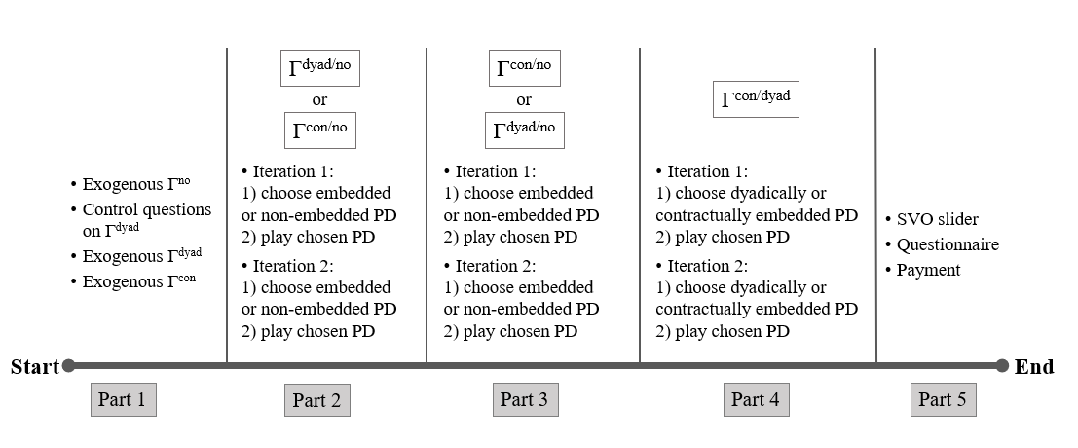
Fig. 1. Experiment timeline

Experimental conditions
Investment cost is either low (5 points), medium (15 points), or high (45 points), and the choice order in Parts 2-3 for all the participants in the session was either Г^{dyad/no} in Part 2 and Г^{con/no} in Part 3, or vice versa. Between-subject design is employed. Three cost conditions and two choice order conditions ultimately make up for six experimental conditions. Table 1 shows the number of sessions and participants for each condition.
Table 1. Number of sessions and participants for each experimental condition
Condition | Number of sessions (14 total) | Number of participants (187 total)
Low cost, Г^{dyad/no} in Part 2 and Г^{con/no} in Part 3 | 2 | 34
Low cost, Г^{con/no} in Part 2 and Г^{dyad/no} in Part 3 | 3 | 36
Medium cost, Г^{dyad/no} in Part 2 and Г^{con/no} in Part 3 | 3 | 30
Medium cost, Г^{con/no} in Part 2 and Г^{dyad/no} in Part 3 | 3 | 37
High cost, Г^{dyad/no} in Part 2 and Г^{con/no} in Part 3 | 2 | 30
High cost, Г^{con/no} in Part 2 and Г^{dyad/no} in Part 3 | 1 | 20

Procedure and participants
The experiment was programmed in zTree software. Participants were recruited through the ORSEE recruitment system. 187 subjects participated in 14 experimental sessions in the ELSE lab at Utrecht University between 05.12.2019 and 11.02.2020. The sessions lasted between fifty and eighty minutes and the average number of participants per session is 13.4 (minimum 4, maximum 22). The average profit was 16.6 euros; earnings were paid to participants in cash at the end of the experiment. Each participant received an endowment of 150 points at the start of the experiment.

In syntax files I address Г^{no} as NE (no embeddedness), Г^{dyad} as RI (repeated interactions), Г^{con} as IC (institutional commitment).

